Short Writing Task: A Picture Story

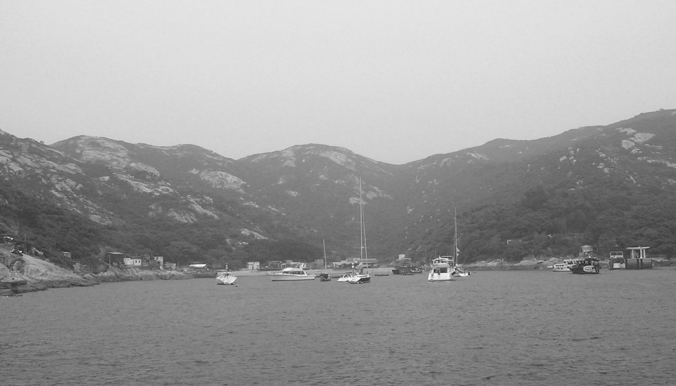
Jane Robbins, used with permission

Write a story about the above picture.
Write approximately 200 words.

END OF QUESTION

Marking Criteria*

Content | - relevance (the narrative fiction is based on the picture or part of it)  - evidence of creativity and imagination (how they develop the story from the picture)
Language and Style | - sentence structure  - grammar and punctuation (e.g. consistent use of narrative tense)  - vocabulary  - register, tone and style
Organization | - coherence  - paragraphing  - cohesion between sentences and paragraphs

- Based on the HKDSE draft descriptors for writing from Hong Kong Diploma of Secondary Education, English Language, Standards-referenced Reporting Information Package. Published by the Hong Kong Examinations and Assessment Authority (2009).

Additional Resources

Narrative essays - http://www.infoplease.com/homework/writingskills4.html
Narrative essays for ESL teachers - http://www.eslflow.com/narrativeessay.html
Writing opening lines - http://litreactor.com/columns/the-top-10-best-opening-lines-of-novels

